1.Write a program to reverse a word using loop?
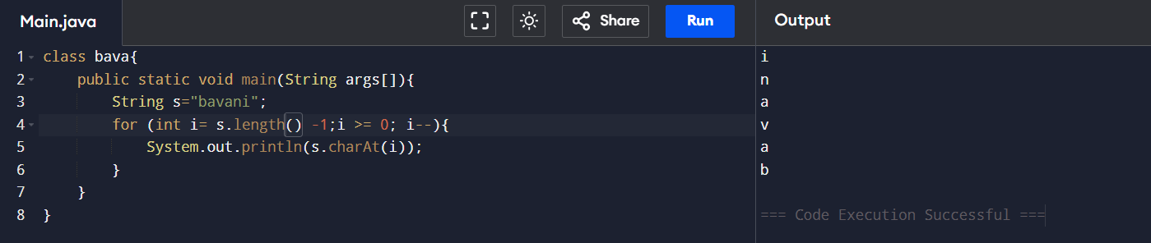

2. Write a program to check the entered user name is valid or not. Get both the inputs from the user.
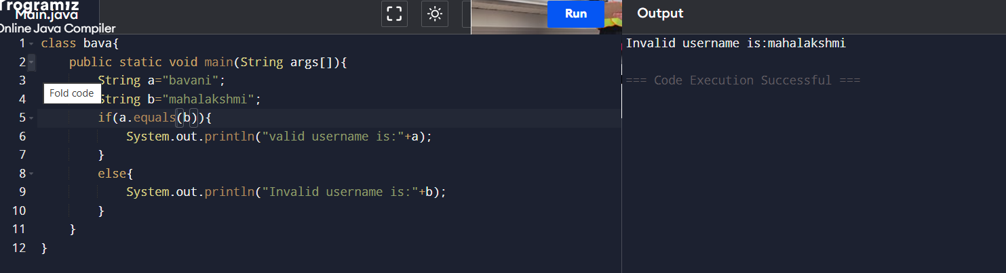
3. Write a program to reverse a number using loop?
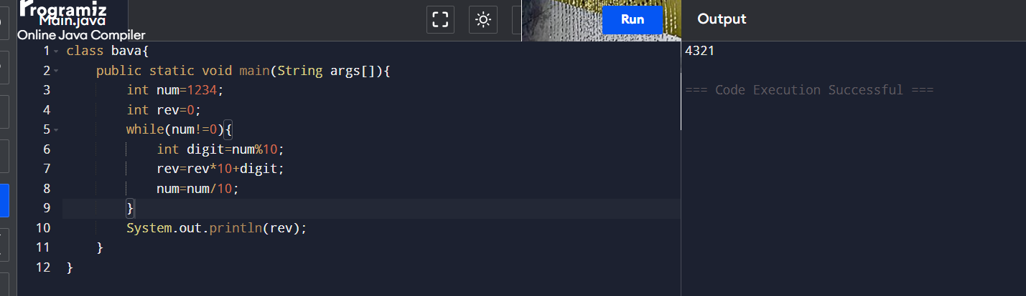

4. Write a program to find whether the person is eligible for vote or not. And if that particular person is not eligible, then print how many years are left to be eligible.
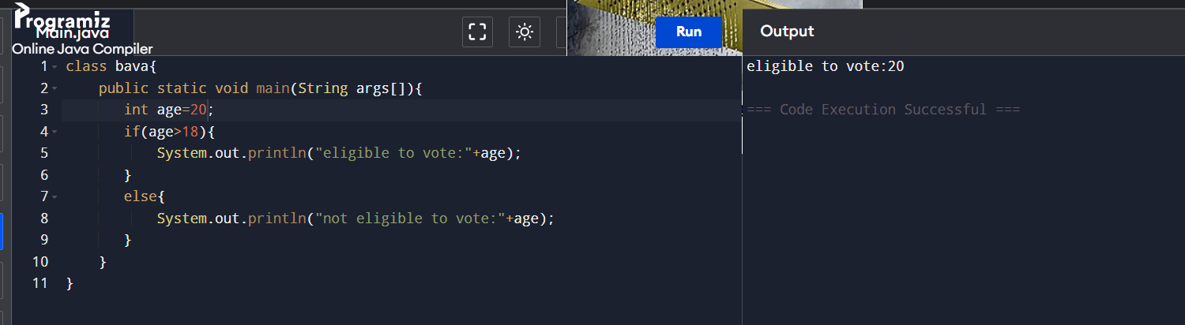
5.Find the LCM and GCD of n numbers?
